**Market Maker Trap False Flag**

Market Maker Trao: False Flags

False Bull Flags In Price Action:

Not all sudden Price Rallies that move into short term consolidations are Bull Flags. In mature Bull Trends or in HTF Distribution Levels - Price will post false Bull Flags.

Retail Traders will see a Classic "continuation buy pattern" but it will result in a Reversal. Understanding Higher Timeframe Charts & Premium Markets will assist in identifying.

False Bear Flags In Price Action:

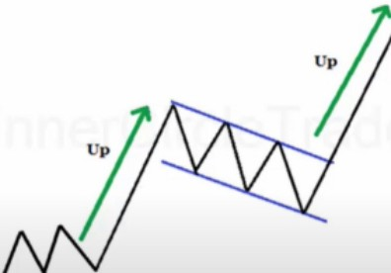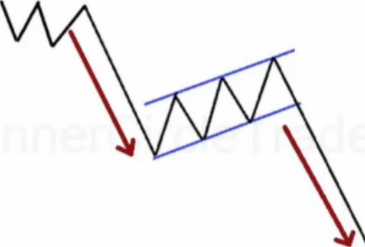1 Not all sudden Price Declines that move into short term consolidations are Bear Flags. In mature Bear Trends or in HTF Accumulation Levels - Price will post false Bear Flags. Retail Traders will see a Classic "continuation sell pattern" but it will result in a Reversal. Understanding Higher Timeframe Charts & Discount Markets will assist in identifying.

When price is still destined to continue, this pattern is pretty consistent. But when youre not aware when the trend is starting to end, these patterns will form at the end of a trend

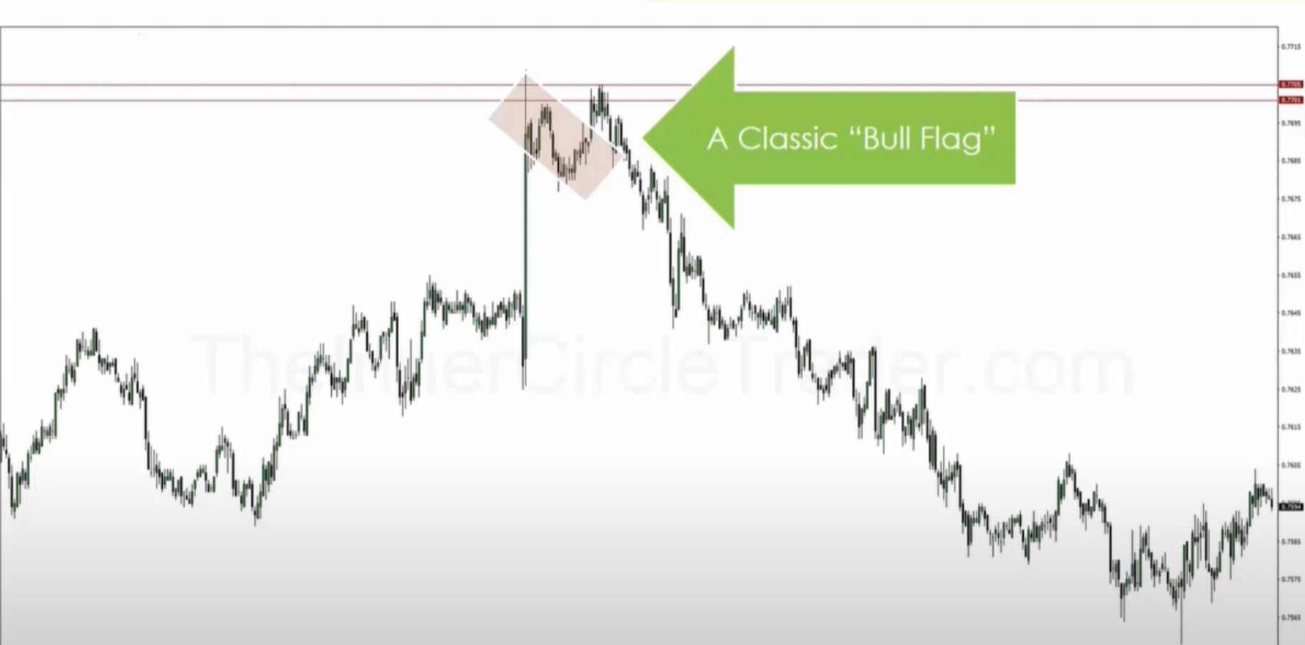

Mean treshold is from body high/low to body low/high, not the wicks He refines a daily orderblock to a 5m unmitigated orderblock

He ignores big news wicks, only looks at the bodies

Its a sentiment play in addition to institutional orderflow on a **HTF**

Look at price action and look what other traders would see, how would retail see the price action

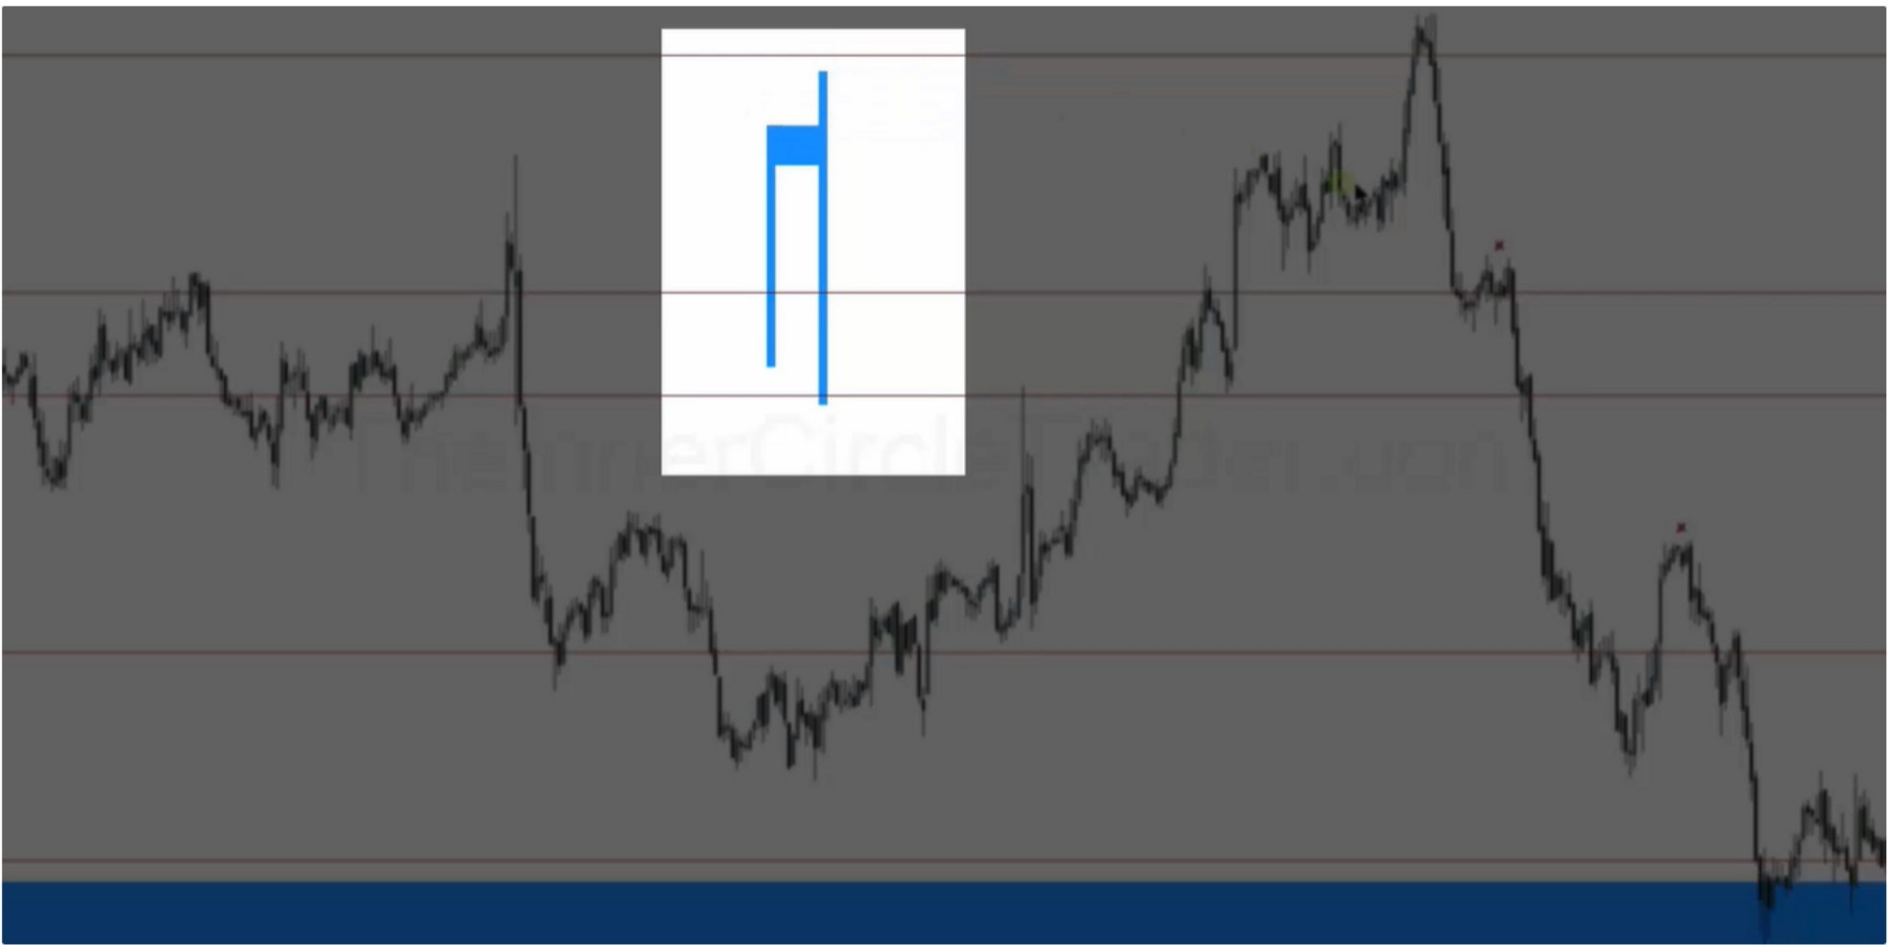

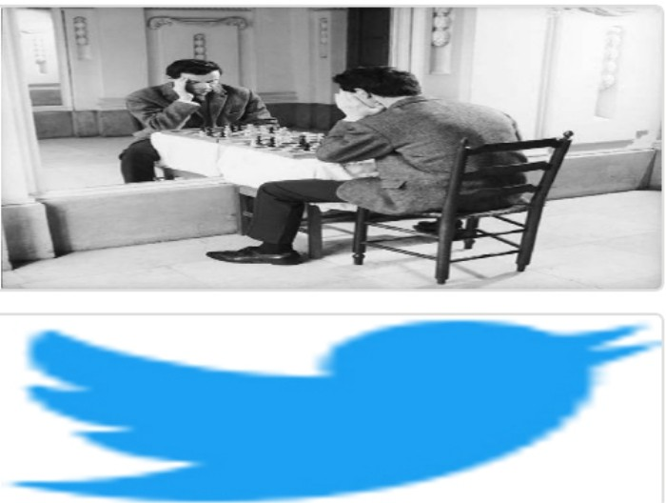Arjo I Twitter, lnstagram I Linktree

Linktree. Make your link do more.

, https://t.co/HhmmTN1fUI

JavaScript is not available.

"# https://twitter.com/arjoio